Robert Call

Linux Admin

12/11/21

**Installing a Minikube on Servers**

My Install of a minikube on each server did not go as smoothly as I had hoped. I found I needed to get drivers for minikube install for both servers. This also led me to two other issues which where I needed to increase memory for both servers. I did this by shutting down both servers and editing the settings and increasing each server by 2gb. This allowed me to install the drivers. The other issue was I needed to update docker drivers and add a newgroup for both. Once done it took a while but centos8 and ubuntu installed the docker drivers needed to run the minikube.

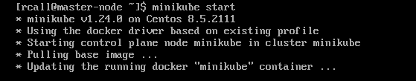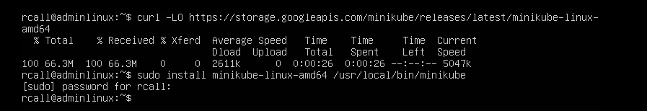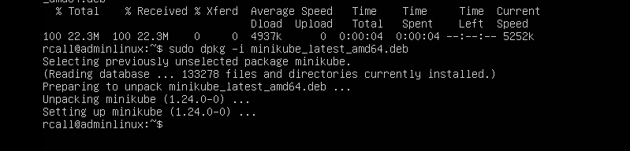

I started minikube on both servers and found I could create the sample deployment for both servers but only one could access the browser it deployed because when the other was successful port 8080 was in use and the browser was in use so it failed. I then setup the minikube tunnel to access the load balancer deployment. Once done we can go to the deployment using the external ip and port 8080.

For the last part of the tutorial, I used the pause and unpause commands





Halted the cluster with minikube stop then used the command with start instead of stop to resume it.

I increased the default memory with the command: minikube config set memory 16384 this will require a restart of my machine. 

Minikube addons list: 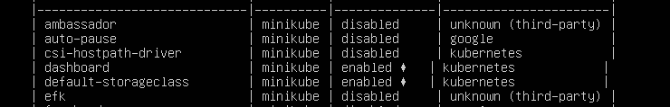

minikube start -p aged --kubernetes-version=v1.16.1 :

Delete all of the minikube clusters:

